ISA PROJECT GUIDE

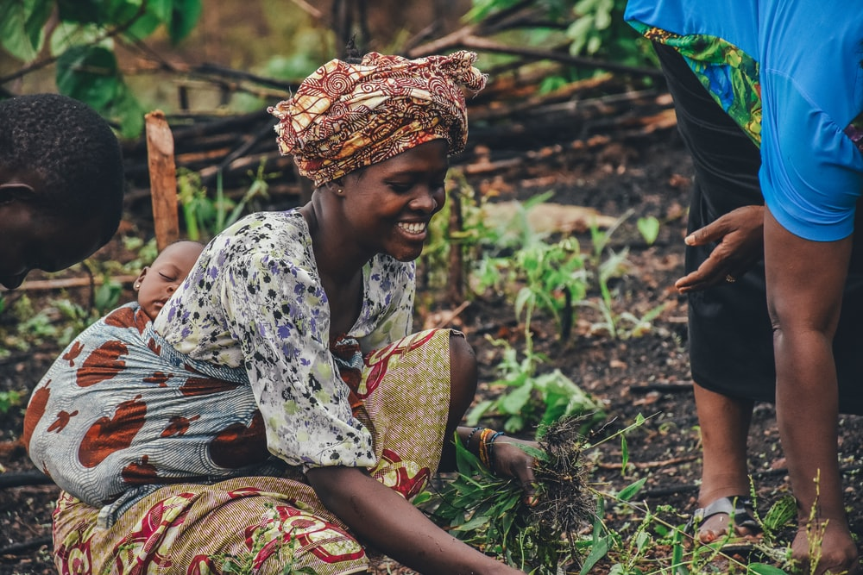
Please replace this photo for one of your own project photos.

Name:
Project Title:
Project Country:
Host Organization:

- Short description of the project (1,000 characters). A precise and concise description of the project that is to be achieved through participation in the scholarship program and which SDG the project can be assigned to. Be aware that your project should be directly contributing to one of the focal goals: SDG 1 (No poverty), SDG 3 (Health and well-being), SDG 4 (Quality education), SDG 8 (Decent work and economic growth), or SDG 12: Sustainable consumption and production and note that SDG 5 (Gender Equality) and SDG 13 (Climate action) should also be considered.

- Vision - What should change through participation in the ISA program (1,000 characters) What should be achieved with the project, what visible improvements can be expected in the short and medium term?

- Framework conditions (12,000 characters)
- Description of the current situation, initial situation (max. 1,500 characters) Detailed description of the situation in the country in relation to the problem, how do the cross-cutting issues fit in?
- Who is the target group, addressees of the project (max. 1,000 characters) For whom should the project change the living situation on the ground and who must be involved. If applicable, who could develop resistance and how should this be dealt with?

- How does the project distinguish itself from other, comparable projects (max. 1,000 characters)? The aspect of innovation should be described, i.e. how the project is new for the region.
- What are my strengths and weaknesses in relation to the project, especially my own experiences, e.g. with the SDGs, stays abroad, civil society engagement, etc.? (max. 1,500 characters) Here you should describe your strengths and weaknesses in relation to the project and especially to your participation in the ISA. Where is the applicant particularly strong and where are competencies missing? The advantages and risks should also be assessed.
- Which SDG is the focus of my work (max. 2,500 characters) Detailed description of the selected SDG with all sub-goals and how the SDG is related to the project.
- What advantages does my home country offer for the implementation (max. 1,000 characters) Description of the given conditions for the implementation of the project in the home country and why the participation in the ISA creates an added value for the region in terms of development policy?
- What contribution does my project make to gender equality (SDG 5) (max. 1,000 characters) Describe the connection between the project and gender issues? The connection must be plausible.
- What contribution does my project make to climate protection (max. 1,000 characters) Description of the project in relation to climate protection?
- What obstacles must be overcome in my home country (max. 1,500 characters) Possible obstacles to implementation and how they can be overcome

- Objectives (detailed description and network plan with time sequence including participation in the ISA and implementation in the home country with milestones and sub-objectives) (max. 4,000 characters) Description of the objectives and sub-objectives to be achieved through participation. The chronological sequence should describe the steps that have already been taken or were taken before the start of the ISA program as well as the time in the program until after the return with successful implementation.

- Concrete expectations of participation in the ISA program and expected added value through cooperation with other scholarship holders (max. 4,000 characters).
The expectations of participation in the ISA and the form of cooperation with other scholarship holders should be described here. It should be clearly recognizable that joint work will bring added value to one's project and that new partnerships to achieve the goals (SDG 17) will be sought through the ISA. This question is related to the soft skills you are willing to share with the other participants and the skills potentially valuable for your project development that you are hoping other fellows to have. The link to SDG 17 (Partnerships for the goals) can be presented here.

- Brief description of the financial means and other resources required for implementation in the home country and how these are to be obtained (max. 1,000 characters). It must be clear that the project can actually be implemented after the return and does not fail from the onset, e.g. due to a lack of funds. If applicable, a convincing explanation of the acquisition of funds that are not available can be positively evaluated.

- Supporters and possible partner organisations in the home country and their respective roles in the realisation of the project (max. 1,000 characters). If other organisations, authorities, and universities are necessary for the implementation, they should be described and their respective roles - if there are no partners, it should be explained how the project can still be implemented. The link to SDG 17 (Partnerships for the goals) can be presented here.

- Controlling (how will it be ensured that the project is realised in the home country and which instruments are used for measurable monitoring) (max. 1,500 characters).
How will the applicants ensure that the project is monitored, and what role should the ISA play in this monitoring?

- How will the project be presented publicly back home? How will the results be published for other interested parties? (max. 2,000 characters). Since the ISA is publicly funded, it is important to disseminate the results, including the individual projects. What ideas do the applicants have to make the results available to the public and especially to interested parties from other regions?

- How will the sustainable implementation of my project be after I return to my home country? What will be different? (max. 2,000 characters) Description of how the further work will be structured and how the results of the ISA will be incorporated into the implementation in the home country and how success will be measured.

